CHAPTER SIX

A MOLECULAR PHYLOGENY OF THE NEOTROPICAL BUTTERFLY TRIBE OLERIINI (LEPIDOPTERA: NYMPHALIDAE: ITHOMIINAE)

Abstract
Here I present gene genealogies for 41 of the approximately 60 butterfly species of the tribe Oleriini (Lepidoptera: Nymphalidae: Ithomiinae), based on data from three different gene regions; 1072 base pairs (bp) of elongation factor 1-α, 417 bp of wingless, and 1619 bp of the mitochondrial genes cytochrome oxidase I and II, plus the intervening tRNA. In all but one case (Hyposcada taliata for the mitochondrial region), species within the Oleriini clustered into the appropriate four genera: Hyposcada, Megoleria, Ollantaya and Oleria. Neighbour-joining analyses of individual gene regions and combined data, and maximum parsimony analysis of combined data recovered Hyposcada as sister to all other Oleriini. However a Bayesian analysis of combined data identified Megoleria as sister to all other Oleriini. The latter arrangement is consistent with previous findings based on morphological and molecular evidence. Species within Oleria have previously been assigned to groups based on morphological characters. The phylogenetic hypotheses presented here suggest that the ‘onega’ species group is valid, but that additional molecular data is required to determine validity of the other species groups. Further molecular work, and the incorporation of morphological evidence, will enable a complete and robust species-level phylogeny to be generated for this tribe. This will be coupled with detailed distributional data to investigate patterns of diversification across the Oleriini.

Introduction
This chapter marks the beginning of a long-term, collaborative project on the Oleriini butterfly tribe (Lepidoptera: Nymphalidae: Ithomiinae). Until very recently the systematics of the Oleriini were poorly understood, in part due to taxonomic difficulties of cryptic morphology, undescribed life stages, and differences between the sexes. These difficulties resulted in a number of classifications being proposed, for example, Fox (1968) placed the Hyposcada, Oleria and Aeria in the Oleriini. However, based on larval morphology and host associations, Aeria has since been recognised as member of a distinct tribe (Ackery 1988, Brown & Freitas 1994). Motta (2003) moved Oleria, Ollantaya, Megoleria, and Hyposcada, as well as most of the genera recognised as belonging to the Napeogenini and Ithomiini by Lamas (2004), into a larger Ithomiini tribe. For the purpose of this chapter, Oleriini is regarded as a monophyletic tribe containing four genera; Hyposcada, Oleria, and the more recently described Ollantaya and Megoleria. This is in accordance with classifications by Harvey (1991), and Lamas (2004), and also with molecular data (Brower et al. 2005).
A major aim of the Oleriini project is to describe the genealogical relationships between all species within the Oleriini. These molecular systematic findings, in conjunction with detailed morphological and ecological information currently being accumulated by K. R. Willmott, will form the basis of a thorough revision of the Oleriini tribe.
When complete and robust species-level phylogenies of the Oleriini have been established, they will be coupled with detailed distributional data to test between hypotheses of Neotropical diversification. A number of features of this tribe make it particularly suitable for such analysis. First, the Oleriini is very speciose, and contains many taxa with restricted geographic ranges. In addition, it was predicted to contain some members resulting from recent as well as older radiations. These factors suggest that members of the Oleriini might have retained important signatures, such as the geographical context, of their speciation. Secondly, the Oleriini are distributed from Mexico to Southern Brazil, and therefore provide an opportunity to test between theories of diversification both on a local scale and from a wider phylogeographical perspective. Thirdly, members of the Oleriini are distributed over a wide altitudinal range (0-3000 m). A number of authors have debated whether Tropical biodiversity can largely be attributed to diversifications in montane regions (Fjeldsä et al. 1994, Roy et al. 1997) or lowland regions (Brown 1957, Barkman & Simpson 2001). Oleriini diversity peaks in the Ecuadorian and Peruvian Andes, as well as in nearby Amazonian lowlands, so the Oleriini provide a model group for testing the relative contributions made by different elevations to Neotropical diversity.
Here, I use data from three different gene regions, elongation factor 1-α (Ef1α), wingless (wg), and the mitochondrial genes cytochrome oxidase I and II (COI and COII) plus their intervening tRNA, in order to infer species level genealogies representing 41 of the approximately 60 species belonging to the Oleriini.

Materials and methods

Taxonomic sampling and DNA extraction
103 individuals representing 41 species of the Oleriini were examined (7 Hyposcada, 2 Ollantaya, 2 Megoleria and 30 Oleria) (Table 1). These samples were collected by the author and preserved in 20% dimethylsulphoxide, 0.25M EDTA and saturated NaCl solution, or donated by collaborators as dried specimens or preserved in alcohol. Typically DNA was extracted from one third of a thorax (but sometimes from just one or two meso- and metathoracic legs) using the DNAeasy kit (QIAgen), according to the manufacturer’s instructions, with an initial 3 h incubation at 55°C, and a final elution volume of 300 μl. In addition, DNA from three samples obtained from the Brower laboratory (E32-1, B16-7, E16-3) had previously been amplified. Sequence data for two ithomiine outgroups, Ithomia drymo and Hyalyris antea, was obtained from Genbank (Brower et al. 2005).

Primer development, PCR and sequencing
PCRs were typically performed in a 50 µl volume, using 4 µl template DNA, 1 x PCR buffer (0.1 M Tris HCl, 0.5 M KCl, 0.01 volumes Triton X-100), 0.2µM dNTPs, 0.3 U/µl Taq and; for COI and COII: 16 µM MgCl₂, 0.08 µM each primer; for wg and Ef1α: 5 µM MgCl₂, 0.2 µM each primer (Table 2); with an amplification profile of; a 2 min denaturation at 94ºC, followed by; COI: 32 cycles of (94ºC for 60 sec, 60ºC for 60 sec, 72ºC for 90 sec); COII: 33 cycles of (94ºC for 60 sec, 56ºC for 60 sec, 72ºC for 90 sec); wg: 30 cycles of (94ºC for 60 sec, 62.5ºC for 60 sec, 72ºC for 60 sec), increased to 35 cycles with a 57.5ºC annealing temperature if quality of template was poor; Ef1α: 30 cycles of (94ºC for 60 sec, 62ºC for 60 sec, 72ºC for 90 sec); all then followed by a final 10 min extension at 72ºC.
Depending on the quality of the PCR products, they were either purified directly using the QIAquick PCR purification kit (QIAgen), or excised from an agarose gel and purified using the QIAquick gel extraction kit (QIAgen), according to the manufacturer’s protocols. Purified products were sent to a commercial company (Macrogen, Korea) or cycle-sequenced in a MJ Research DNA Engine, precipitated using ethanol or ethanol and sodium acetate, and run on an ABI 373 automated sequencer using ABI protocols with the PCR primers. In cases where chromatograms did not read for the full sequence length, sequencing was also performed with additional sequencing primers (Table 2).

Data analyses
Sequences were edited using SeqEd v1.0.3 software (Applied Biosystems). PAUP version 4.0b 10 (Swofford 2000) was used to calculate the numbers of variable and parsimony informative sites, nucleotide composition, and to perform a chi-square test of base frequency homogeneity for each gene region. Due to computing constraints, Neighbour Joining (NJ) analysis only was performed in PAUP for each gene region individually, as well as for combined data. Two combined datasets were analysed; ‘total’ data which included all available data, and ‘complete’ data which included only those individuals for which data was available for all three gene regions. NJ trees were generated using HKY85 distances with random break ties. Confidence in each node was assessed by performing 1000 rounds of NJ bootstrapping.
In addition, maximum parsimony (MP) topologies were conducted on the ‘complete’ data set in PAUP using a 10-replicate heuristic search with tree-bisection-reconnection (TBR) branch swapping, with random stepwise addition of sequences. These were summarized with a 95% majority rule consensus tree. To dissect the contributions of the individual genes in recovering relationships at different taxonomic levels in the ‘complete’ dataset, partitioned Bremer support values (Baker & DeSalle 1997) were calculated using TreeRot (Sorenson 1999). Bayesian analysis was also performed on the ‘complete’ data set with just one outgroup taxa (MrBayes 3.0, Huelsenbeck & Ronquist 2001) using parameters identified by Modeltest 3.04 (nst=6, rates=invgamma), with four simultaneous chains run for 1,000,000 generations, sampling a tree every 100 generations. A consensus tree with branch support in the form of posterior probabilities was derived from the final 9,000 trees (representing the final 900,000 generations), after confirmation that likelihood values had stabilized.
Table 1. Specimen information and Genbank accession codes.

Taxa | Specimen number | Collection locality | mito-  chondrial | wg | Ef1α | Collected or donated by: | Wing voucher | Available tissue | Available DNA template
H anchiala ecuadorina | Ec 452 | ECUADOR:  Napo: Jatun Sacha.  01º 04’S, 77º 36’W | DQ078474 | DQ143816 | X | A. Whinnett & R. Naisbit | UCL | UCL (Ecuador collection) | UCL (Oleriini collection)
H anchiala fallax | 02-3519 | PERU: Madre de Dios: Mazuko.  13º 06’S 70º 22’W | DQ078477 | DQ085434 | DQ085446 | J. Mallet  et al. | missing | UCL (Peru collection 2002) | UCL (Oleriini collection)
H anchiala interrupta | 02-512 | PERU: San Martín: km 7.2 Pongo-Barranquita. 06º 17’20S, 76º 13’41W | DQ078355 | DQ143817 | X | J. Mallet  et al. | UCL | UCL (Peru collection 2002) | UCL (Oleriini collection)
H anchiala interrupta | 02-2105 | PERU: San Martín: km 7.2 Pongo-Barranquita. 06º 17’20S, 76º 13’41W | DQ078356 | DQ085433 | DQ085445 | J. Mallet  et al. | UCL | UCL (Peru collection 2002) | UCL (Oleriini collection)
H anchiala interrupta | 02-1293 | PERU: San Martín: km 7.2 Pongo-Barranquita. 06º 17’20S, 76º 13’41W | DQ078312 | DQ143818 | X | J. Mallet  et al. | UCL | UCL (Peru collection 2002) | UCL (Oleriini collection)
H anchiala mendax | 02-1644 | PERU: San Martín: Puente Serranoyacu. 05º40’S, 77º40’W | DQ078357 | DQ085435 | DQ085447 | J. Mallet  et al. | UCL | UCL (Peru collection 2002) | UCL (Oleriini collection)
H anchiala mendax | 02-1645 | PERU: San Martín: Puente Serranoyacu. 05º40’S, 77º40’W | DQ078358 | DQ143819 | X | J. Mallet  et al. | UCL | UCL (Peru collection 2002) | UCL (Oleriini collection)
H anchiala mendax | 02-716 | PERU: San Martín: Puente Serranoyacu. 05º40’S, 77º40’W | DQ078359 | DQ143820 | X | J. Mallet  et al. | UCL | UCL (Peru collection 2002) | UCL (Oleriini collection)
H anchiala mendax | 02-1602 | PERU: San Martín: La Antena. 06º 27’18S, 76º 17’54W | DQ078360 | - | - | J. Mallet  et al. | UCL | UCL (Peru collection 2002) | UCL (Oleriini collection)

H anchiala mendax | 02-2141 | PERU: San Martín: La Antena. 06º 27’18S, 76º 17’54W | DQ078361 | - | - | J. Mallet  et al. | UCL | UCL (Peru collection 2002) | UCL (DNA extracts 2005)
H anchiala richardsi | G1  (cp 8-17) | PERU: Madre de Dios: Río Los Amigos.  12º 35’S 70º 5’W | DQ078475 | - | - | C. Peña & G. Lamas | MHN, Lima | UCL (Oleriini collection) | UCL (Oleriini collection)
H illinissa napoensis | K6 (KRW-11/2/04-6) | ECUADOR: Napo, Río Yuturi, Río Manduro trail, Río Napo. 0°33.49'S,76°2.65'W | X | - | - | K. R. Willmott | K. R. Willmott | Extracted whole donated sample | UCL (dried STRI collection)
H illinissa ida | K7 (KRW-11/2/04-6) | ECUADOR: Napo, Río Yuturi, lodge trail, Río Napo. 0°32.88'S,76°2.48'W | X | - | - | K. R. Willmott | K. R. Willmott | Extracted whole donated sample | UCL (dried STRI collection)
H illinissa ssp nov 4 | 02-1187 |  | X | DQ143822 | X | J. Mallet  et al. | UCL | UCL (Oleriini collection) | -
  PERU: Km 28, Tarapoto - Yurimaguas, San Martin
  06º 41’19S, 76º 31’76W
H illinissa margarita | 02-190 | PERU:  San Martín: Chumía.  06º 36’57S, 76º 11’10W | X | DQ143823 | X | J. Mallet  et al. | UCL | UCL (Peru collection 2002) | -
H illinissa | Ec 455 | ECUADOR:  Napo: Jatun Sacha.  01º 04’S, 77º 36’W | X | DQ143821 | X | A. Whinnett & R. Naisbit | UCL | UCL (Ecuador collection) | UCL (Oleriini collection)
H kena | Ec 458 | ECUADOR:  Napo: Jatun Sacha.  01º 04’S, 77º 36’W | X | DQ143825 | X | A. Whinnett & R. Naisbit | UCL | UCL (Ecuador collection) | UCL (Oleriini collection)
H kena flexibilis | 02-197 | PERU:  San Martín, Chumía.  06º 36’57S, 76º 11’10W | DQ078362 | - | - | J. Mallet  et al. | UCL | UCL (Peru collection 2002) | UCL (DNA extracts 2005)
H kena flexibilis | 02-198 | PERU:  San Martín, Chumía.  06º 36’57S, 76º 11’10W | DQ078363 | DQ085436 | DQ085448 | J. Mallet  et al. | UCL | UCL (Peru collection 2002) | UCL (DNA extracts 2005)

H kena flexibilis | 02-1591 | PERU: San Martin, 5 km after Shapaja | DQ078364 | - | - | J. Mallet  et al. | UCL | UCL (Peru collection 2002) | UCL (DNA extracts 2005)
H kena ssp nov | 02-1666 | PERU: San Martín: Puente Serranoyacu. 05º40’S, 77º40’W | DQ078365 | DQ143824 | X | J. Mallet  et al. | UCL | UCL (Peru collection 2002) | UCL (DNA extracts 2005)
H kena ssp nov | 02-1670 | PERU: San Martín: Puente Serranoyacu. 05º40’S, 77º40’W | DQ078366 | - | - | J. Mallet  et al. | UCL | UCL (Peru collection 2002) | UCL (DNA extracts 2005)
H kena ssp nov | 02-1667 | PERU: San Martín: Puente Serranoyacu. 05º40’S, 77º40’W | DQ078367 | - | - | J. Mallet  et al. | UCL | UCL (Peru collection 2002) | UCL (DNA extracts 2005)
H schausi lactea | K5 | ECUADOR: Esmeraldas, Río Chuchuví, km 12.5 Lita-San Lorenzo rd.. 0°52.85'N,78°30.90'W | X | - | - | K. R. Willmott | UCL | Extracted whole donated sample | UCL (dried STRI collection)
H taliata | 02-1696 | PERU:  San Martin, Rio Nieva. 05º 41’17S 77º 46’54W | X | DQ143826 | X | J. Mallet  et al. | UCL | UCL (Peru collection 2002) | UCL (Oleriini collection)
H virginiana | 8283 | PANAMA:  Cerro Campana.  08º 68’74N 79º 91’97W | DQ078476 | DQ143828 | X | C. Jiggins | Edinburgh | UCL (Oleriini collection) | UCL (Oleriini collection)
H virginiana evanides | 8339 | PANAMA: Quebrada Hornito Trail, Fortuna. 08º 69’28N 82º 22’45W | X | DQ143829 | X | C. Jiggins | Edinburgh | Contact Jiggins (Edinburgh) | UCL (Oleriini collection)
H virginiana | 8000 | PANAMA: Quebrada Hornito Trail, Fortuna. 08º 69’28N 82º 22’45W | X | DQ143827 | X | C. Jiggins | Edinburgh | UCL (Oleriini collection) | UCL (Oleriini collection)
H zarepha zarepha | 02 K | FRENCH GUIANA: Camp Patawa, route de Kaw | X | DQ143830 | - | Stephane Attal | UCL | UCL (Oleriini collection) | UCL (Oleriini collection)

Megoleria orestilla | 18-IK | 18-I ECUADOR: Prov. Zamora-Chinchipe, km 40 Loja- Zamora. | X | DQ143832 | X | K. R. Willmott | 18-I UCL | 18-I Tissue UCL (Oleriini collection) | 18-I UCL (Oleriini collection)
Megoleria orestilla | 18-1K | 18-1 ECUADOR: Sucumbíos, Quebrada El Garrapatal, nr. La Bonita | - | - | - | K. R. Willmott | 18-1 UCL | 18-1 Tissue UCL (Oleriini collection) | 18-1 UCL (Oleriini collection)
Megoleria orestilla | Ec 402 | ECUADOR: Yanayacu, near Cosanga | X | DQ143831 | X | A. Whinnett & R. Naisbit | UCL | UCL (Oleriini collection) | -
Megoleria susiana | M27 | ECUADOR: Napo, Cordillera Guacamayos, Baeza-Tena rd., Cocodrilo area. | - | DQ143833 | - | Ismael Aldas | NHM, London | Extracted whole donated sample | -
Ollantaya aeginata | E 32-1 | ECUADOR: Prov. Zamora-Chinchipe, Zamora | DQ157526 | To submit | To submit | K. R. Willmott | OSU | OSU | OSU
Ollantaya olerioides | 13-19K | ECUADOR: Sucumbíos, Río Sucio, nr. La Bonita. 0°28.50'N,77°33.30'W, | - | DQ143834 | X | K. R. Willmott | UCL | UCL (Oleriini collection) | -
O agarista agarista | 02-294 |  | DQ078368 | - | - | J. Mallet  et al. | UCL | UCL (Peru collection 2002) | UCL (DNA extracts 2005)
  PERU: San Martin, Km 7.2, Pongo- Barranquita.
  06º 17’20S 76º 13’41W
O agarista agarista | 02-1307 | PERU: San Martin, Km 7.2, Pongo- Barranquita. 06º 17’20S 76º 13’41W | DQ078369 | - | - | J. Mallet  et al. | UCL | UCL (Peru collection 2002) | UCL (DNA extracts 2005)
O agarista agarista | 02-293 | PERU: San Martin, Km 7.2, Pongo- Barranquita. 06º 17’20S 76º 13’41W | DQ078370 | DQ143836 | X | J. Mallet  et al. | UCL | UCL (Peru collection 2002) | UCL (DNA extracts 2005)

O alexina didymaea | 02-3370 | (Contact M. Zimmermann) | X | DQ143837 | X | J. Mallet  et al. | UCL | UCL (Oleriini collection) | -
O amalda modesta | Ec 135 | ECUADOR: near Hotel Tinalandia, Alluriquin. | X | DQ143838 | X | A. Whinnett & R. Naisbit | UCL | UCL (Oleriini collection) | -
O aquata | B16-7 | BRAZIL:  São Paulo, Jundia. | DQ168618 | DQ168620 | DQ168616 | A. Freitas | OSU | OSU | OSU
O assimilis pilcopata | 02-3609 | PERU:  Cuzco, Quincemil | DQ085456 | DQ085438 | DQ085450 | J. Mallet et al. | missing | UCL (Peru collection 2002) | To check
O assimilis | 16-8K | ECUADOR: Sucumbíos, El Recodo, La Bonita-Lumbaqui rd. | X | DQ143839 | X | K. R. Willmott | UCL | UCL (Oleriini collection) | UCL (Oleriini collection)
O athalina banjana | Ec 415 | ECUADOR:  Yanayacu, near Cosanga | X | - | - | A. Whinnett & R. Naisbit | UCL | UCL (Oleriini collection) | -
O athalina banjana | 11-6K | ECUADOR: Sucumbìos, Old rd. to La Alegría, km 19 La Bonita-Tulcan rd.. 0°33.70'N,77°31.70'W | - | DQ143840 | X | K. R. Willmott | UCL | UCL (Oleriini collection) | UCL (Oleriini collection)
O attalia | 35-1K | ECUADOR: Zamora-Chinchipe, San Francisco, canal subterraneo, Zamora-Loja rd.. 3°58.74'S,79°5.13'W | X | DQ143841 | X | K. R. Willmott | missing (contact KRW) | Extracted whole donated sample | UCL (Oleriini collection)
O baizana | Ec 413 | ECUADOR:  Yanayacu, near Cosanga | - | DQ143842 | X | A. Whinnett & R. Naisbit | UCL | - | UCL (Oleriini collection)
O bioculata tapio | 02-1611 | PERU:  San Martín: La Antena. 06º 27’18S, 76º 17’54W | X | DQ143843 | X | J. Mallet  et al. | UCL | UCL (Oleriini collection) | -

O boyeri | Boy | VENEZUELA:  Estado Bolívar, La Escalera km 129 | X | - | X | J. Mavarez | UCL | STRI | STRI
O cyrene solida | Ec 394 | ECUADOR: Yanayacu, near Cosanga | X | DQ143844 | X | A. Whinnett & R. Naisbit | UCL | UCL (Oleriini collection)**/  UCL (Ecuador collection) | UCL (Oleriini collection)
O estella | 02-406 | PERU:  San Martín: La Antena. 06º 27’18S, 76º 17’54W | X | DQ143845 | X | J. Mallet  et al. | UCL | UCL (Oleriini collection) | -
O fasciata fasciata | 9-2K | ECUADOR: Sucumbìos, Río Sucio, nr. La Bonita. 0°28.50'N,77°33.30'W | X | DQ143846 | X | K. R. Willmott | UCL | UCL (Oleriini collection) | UCL (Oleriini collection)
O fumata | K14 | W. COLOMBIA | X | - | - | L. Constantino | UCL | UCL (Oleriini collection) | UCL (dried STRI collection)
O fumata | K13 | W. COLOMBIA | X | - | - | L. Constantino | UCL | UCL (Oleriini collection) | UCL (dried STRI collection)
O gunilla lota | 02-1304 | PERU: San Martin, Km 7.2, Pongo- Barranquita. 06º 17’20S 76º 13’41W | DQ078374 | DQ143848 | X | J. Mallet  et al. | UCL | UCL (Oleriini collection) | -
O gunilla lota | 02-2118 | PERU: San Martin, Km 7.2, Pongo- Barranquita. 06º 17’20S 76º 13’41W | DQ078375 | - | - | J. Mallet  et al. | UCL | UCL (Peru collection 2002) | UCL (DNA extracts 2005)
O gunilla lota | 02-290 | PERU: San Martin, Km 7.2, Pongo- Barranquita. 06º 17’20S 76º 13’41W | DQ078376 | - | - | J. Mallet  et al. | UCL | UCL (Peru collection 2002) | UCL (Oleriini collection)
O gunilla serdolis | 02-1580 | PERU: San Martin, 5 km after Shapaja | DQ078377 | DQ143847 | X | J. Mallet  et al. | UCL | UCL (Peru collection 2002) | UCL (DNA extracts 2005)

O gunilla serdolis | 02-196 | PERU:  San Martín: Chumía. 06º 36’57S, 76º 11’10W | DQ078379 | - | - | J. Mallet  et al. | UCL | UCL (Peru collection 2002) | UCL (DNA extracts 2005)
O gunilla serdolis | 02-194 | PERU:  San Martín: Chumía. 06º 36’57S, 76º 11’10W | DQ078378 | - | - | J. Mallet  et al. | UCL | UCL (Peru collection 2002) | UCL (DNA extracts 2005)
O gunilla lota | Ec 467 | ECUADOR:  Napo: Jatun Sacha. 01º 04’S, 77º 36’W | DQ085457 | DQ085439 | DQ085451 | A. Whinnett & R. Naisbit | UCL | UCL (Oleriini collection) | -
O ilerdina lerida | 02-1301 | PERU: San Martin, Km 7.2, Pongo- Barranquita. 06º 17’20S 76º 13’41W | DQ078371 | DQ143849 | X | J. Mallet  et al. | UCL | UCL (Oleriini collection) | UCL (DNA extracts 2005)
O ilerdina lerida | 02-1302 | PERU: San Martin, Km 7.2, Pongo- Barranquita. 06º 17’20S 76º 13’41W | DQ078372 | - | - | J. Mallet  et al. | UCL | UCL (Peru collection 2002) | UCL (DNA extracts 2005)
O ilerdina lerida | 02-2023 |  | X | DQ143850 | X | J. Mallet  et al. | UCL | UCL (Oleriini collection) | -
  PERU: San Martin Km 26, Yurimaguas- Tarapoto
O ilerdina lerida | 02-291 | PERU: San Martin, Km 7.2, Pongo- Barranquita. 06º 17’20S 76º 13’41W | DQ078373 | - | - | J. Mallet  et al. | UCL | UCL (Peru collection 2002) | UCL (DNA extracts 2005)
O makrena | 6-3 | ECUADOR:  Sucumbíos, km 8 La Bonita-Tulcán rd.. 0°30.90'N,77°31.50'W, | X | DQ143835 | - | K. R. Willmott | missing (contact KRW) | UCL (Oleriini collection) | -
O makrena | K16 | W. COLOMBIA | X | - | - | L. Constantino | UCL | UCL (Oleriini collection) | UCL (dried STRI collection)
O makrena | K15 | COLOMBIA: Antioquia, Amagá, Finca el Socorro, Vereda la Florida | X | - | - | L. Gomez Piñerez | UCL | - | UCL (dried STRI collection)
O makrena makrenita | Ec 409 | ECUADOR: Yanayacu, near Cosanga | X | DQ143852 | X | A. Whinnett & R. Naisbit | UCL | -

O onega ssp nov | 02-1708 | PERU: San Martín: Puente Serranoyacu. 05º40’S, 77º40’W | DQ078380 | DQ143855 | X | J. Mallet  et al. | UCL | UCL (Peru collection 2002) | UCL (Oleriini collection)
O onega ssp nov | 02-1709 | PERU: San Martín: Puente Serranoyacu. 05º40’S, 77º40’W | DQ078381 | DQ143856 | X | J. Mallet  et al. | UCL | UCL (Peru collection 2002) | UCL (Oleriini collection)
O onega ssp nov | 02-1674 | PERU: San Martín: Puente Serranoyacu. 05º40’S, 77º40’W | DQ078382 | DQ143857 | X | J. Mallet  et al. | missing | UCL (Peru collection 2002) | UCL (Oleriini collection)
O onega ssp nov | 02-1173 | PERU: San Martin, 5 km after Shapaja | DQ078383 | - | - | J. Mallet  et al. | UCL | UCL (Peru collection 2002) | UCL (Oleriini collection)
O onega ssp nov | 02-1585 | PERU: San Martin, 5 km after Shapaja | DQ078384 | - | - | J. Mallet  et al. | UCL | UCL (Peru collection 2002) | (Oleriini collection)
O onega ssp nov | 02-1958 | PERU: San Martin, 5 km after Shapaja | DQ078385 | - | - | J. Mallet  et al. | UCL | UCL (Peru collection 2002) | UCL (Oleriini collection)
O onega janarilla | 02-520 | PERU: San Martin, Km 7.2, Pongo- Barranquita. 06º 17’20S 76º 13’41W | DQ078391 | DQ143854 | X | J. Mallet  et al. | UCL | UCL (Peru collection 2002) | UCL (Oleriini collection)
O onega janarilla | 02-1165 | PERU: San Martin, 5 km after Shapaja | DQ078386 | - | - | J. Mallet  et al. | UCL | UCL (Peru collection 2002) | UCL (DNA extracts 2005)
O onega janarilla | 02-521 | PERU: San Martin, Km 7.2, Pongo- Barranquita. 06º 17’20S 76º 13’41W | X | - | - | J. Mallet  et al. | UCL | UCL (Peru collection 2002) | -
O onega janarilla | 02-1583 | PERU: San Martin, 5 km after Shapaja | DQ078387 | - | - | J. Mallet  et al. | UCL | UCL (Peru collection 2002) | UCL (DNA extracts 2005)
O onega janarilla | 02-1960 | PERU: San Martin, 5 km after Shapaja | DQ078388 | - | - | J. Mallet  et al. | UCL | UCL (Peru collection 2002) | UCL (DNA extracts 2005)

O onega janarilla | 02-303 | PERU: San Martin, Km 7.2, Pongo- Barranquita. 06º 17’20S 76º 13’41W | DQ078389 | DQ143853 | X | J. Mallet  et al. | UCL | UCL (Peru collection 2002) | UCL (Oleriini collection)
O onega janarilla | 02-515 | PERU: San Martin, Km 7.2, Pongo- Barranquita. 06º 17’20S 76º 13’41W | DQ078390 | DQ085441 | DQ085453 | J. Mallet  et al. | UCL | UCL (Peru collection 2002) | UCL (Oleriini collection)
O onega janarilla | Ec 277 | ECUADOR: Pastaza, Communidad Shuar Mirador, 70km E of Macas-Puyo | DQ085458 | DQ085440 | DQ085452 | A. Whinnett & R. Naisbit | UCL | UCL (Oleriini collection) | -
O onega ssp nov | 02-835 | PERU: San Martín: Puente Serranoyacu. 05º40’S, 77º40’W | DQ085459 | DQ085442 | DQ085454 | J. Mallet  et al. | missing | To check | UCL (Oleriini collection)
O padilla cajamarcensis | Ec 167 | ECUADOR: Vilcabamba Ecolodge, Eastern Trail from Ruinas Lodge to Rumi Wilco | X | DQ143858 | X | A. Whinnett & R. Naisbit | UCL | UCL (Oleriini collection) | -
O padilla makrena | 02-1699 | PERU:  San Martin, Rio Nieva. 05º 41’17S 77º 46’54W | X | DQ143860 | X | J. Mallet  et al. | UCL | UCL (Oleriini collection) | -
O padilla padilla | Ec 85 | ECUADOR: Mindo | X | DQ143859 | X | A. Whinnett & R. Naisbit | UCL | UCL (Oleriini collection) | -
O padilla | 19-1 | ECUADOR: Pichincha, Palmito Pamba, km 5 Nanegal-Garcia Moreno rd. | - | - | X | K. R. Willmott | UCL | - | UCL (Oleriini collection)
O paula | 8474 | PANAMA: Cerro Campana. 08º 68’74N 79º 91’97 W | X | DQ143861 | X | C. Jiggins | Edinburgh | Contact Jiggins (Edinburgh) | UCL (Oleriini collection)
O quadrata | E16-3 | ECUADOR: Pichincha Prov., San Antonio | DQ168619 | DQ168621 | DQ168617 | K. R. Willmott | OSU | OSU | OSU

O radina ssp nov | 11-2 | ECUADOR: Sucumbíos, Old rd. to La Alegría, km 19 La Bonita-Tulcan rd.. 0°33.70'N,77°31.70'W | X | DQ143862 | X | K. R. Willmott | missing (contact KRW) | UCL (Oleriini collection) | -
O rubescens | 8369 | PANAMA: Chiriqui, Quebrada Hornito. 08º 69’28N 82º 22’45 W | DQ085460 | DQ085443 | DQ085455 | C. Jiggins | Edinburgh | UCL (Oleriini collection) | UCL (Oleriini collection)
O rubescens | 8404 | PANAMA: Continental Divide Trail, Fortuna. 08º 78’53N 82º 21’43 W | X | DQ143863 | X | C. Jiggins | Edinburgh | Contact Jiggins (Edinburgh) | UCL (Oleriini collection)
O santineza | 3-2 | ECUADOR:  Sucumbíos, Río Sucio, , nr. La Bonita. 0°28.50'N,77°33.30'W | To submit | To submit | To submit | K. R. Willmott | missing (contact KRW) | UCL (Oleriini collection) | -
O sexmaculata | M29 | ECUADOR:  Napo, Estación Científica Yasuní, Río Tiputini, via Auca. 0°38.0'S,76°25.0'W, | X | - | - | K. R. Willmott & J. Hall | NHM, London | Extracted whole donated sample | -
O tigilla tigilla | K12 | ECUADOR:  Napo, Pimpilala, Río Jatunyacu | X | - | - | K. R. Willmott | UCL | Extracted whole donated sample | UCL (dried STRI collection)
O tremona | 6-4K | ECUADOR:  Sucumbíos, km 8 La Bonita-Tulcán rd.. 0°30.90'N,77°31.50'W | X | DQ143851 | X | K. R. Willmott | UCL | UCL (Oleriini collection) | UCL (Oleriini collection)
O vicina | 2987 | PANAMA: Continental Divide Trail, Fortuna. 08º 78’53N 82º 21’43 W | X | - | - | C. Jiggins | Edinburgh | UCL (Oleriini collection) | -
O vicina | 8500 | PANAMA: Palo Alto, Boquete. | X | DQ143864 | X | C. Jiggins | Edinburgh | UCL (Oleriini collection) | UCL (Oleriini collection)

O vicina | 8498 | PANAMA: Palo Alto, Boquete. | - | DQ143865 | X | C. Jiggins | Edinburgh | UCL (Oleriini collection)**/ Contact Jiggins (Edinburgh) | UCL (Oleriini collection)
O victorine | 02-3339 | (Contact M. Zimmermann) | X | DQ143867 | X | J. Mallet  et al. | UCL | UCL (Oleriini collection) | -
O victorine sarilis | 02-1458 | PERU: San Martín: Chumía. 06º 36’57S, 76º 11’10W | X | DQ143866 | X | J. Mallet  et al. | UCL | UCL (Oleriini collection) | -
O zelica pagasa | 8396 | PANAMA: Continental Divide Trail, Fortuna. 08º 78’53N 82º 21’43 W | X | DQ143868 | X | C. Jiggins | Edinburgh | UCL (Oleriini collection) | UCL (Oleriini collection)
O zelica | 8-1K | ECUADOR: Imbabura, Rumiñahui, 37 km N Pedro Vicente Maldonado. 0°16.73'N,78°59.9'W |  | - | X | K. R. Willmott | UCL | - | UCL (Oleriini collection)
Ithomia drymo | B16-5 | BRAZIL: São Paulo, Jundia | DQ069238 | DQ073014 | DQ073030 | A. Freitas | OSU | OSU | OSU
Hyalyris antea | E30-4 | ECUADOR: Prov. Zamora-Chinchipe, Quebrada Chorillos | DQ069237 | DQ073013 | DQ073029 | K. R. Willmott | OSU | OSU | OSU

Table 2. Primer details

Primer (name as ordered in OSU) | Region | 5’-3’ Sequence | Source | PCR  primer | Sequencing primer
Jerry-COI | COI | CAACATTTATTTTGATTTTTTGG | Simon et al. 1994 | Y | Y
PatCOI/ Pat2COI | COI | TCCATTACATATAATCTGCCATATTAG | Simon et al. 1994 | Y | Y
Pat-aw | COI | TCCAATGCACTAATCTGCCATATTA | Simon et al. 1994 | Y | Y
OleriiniCOInest | COI | TGATATCATTCAATAGAWGAWGGT | Whinnett |  | Y
COI-int-Oler-aw | COI | ACTCCWGTTAATCCTCCNACA | Whinnett |  | Y
George3-aw | COII | TAGGTITAGCIGGAATACCTCG | Simon et al. 1994 | Y | Y
George IV | COII | TTTAGCTGGAATACCTCGACG | Simon et al. 1994 | Y | Y
Imelda/Imelda-aw | COII | CATTAGAAGTAATTGCTAATTTACTA | Simon et al. 1994 | Y | Y
COII-Ol-intfo-aw | COII | CANGARTGAATAACATCAGTAGCAG | Whinnett |  | Y
COII-Ol-intrev-aw-r | COII | CTGCTACTGATGTTATTCAYTCNTG | Whinnett |  | Y
WG1 | wg | GARTGYAARTGYCAYGGYATGTCTGG | Brower and DeSalle 1998 | Y | Y
WG2 | wg | ACTICGCRCACCARTGGAATGTRCA | Brower and DeSalle 1998 | Y | Y
EF1a-fo-aw | Ef1α | CTGAGCGYGARCGTGGTAT | Whinnett, from Cho et al. 1995 | Y
EF1a-rev-aw | Ef1α | ACAGCNACKGTYTGYCTCAT | Whinnett, from Cho et al. 1995 | Y | Y
Ithom-EF-fo | Ef1α | TCGAAACCGCTAARTTCTATGT | Whinnett |  | Y
EF-int-Oleriini-aw | Ef1α | ATCGCTCTGTGGAAGTTCG | Whinnett |  | Y
EF-Ol-fo2-aw | Ef1α | AGACAACGTAGGTTTCAACG | Whinnett |  | Y
EF-1alphaM46Al | Ef1α | GAGGAAATYAARAAGGAAG | Murray, from Cho et al. 1995 |  | Y
EF-1alphaM51Monica | Ef1α | CATRTTGTCKCCGTGCCAKCC | Murray, from Cho et al. 1995 |  | Y

Results and Discussion
Molecular results
Sequence data was obtained from 103 individuals of the Oleriini; 67 individuals for Ef1α, 67 for wg, and 96 for the mitochondrial region. The final alignment spans 1072 bp of Ef1α, 417 bp of wg, and 1619 bp of mitochondria CO region. As expected, the mitochondrial region evolved the fastest: excluding the outgroup taxa; 156 (14.6%) sites were variable for Ef1α, of which 102 were parsimony informative (PI); 94 (22.5%) sites were variable (72 PI) for wg; and 576 (35.6%) sites were variable (479 PI) for the mitochondrial region. Of 45 branches with Bremer support values (Figure 1), 35, 4 and 6 were most strongly support by the mitochondrial, Ef1α and wg partitions respectively (an additional branch was equally supported by all partitions). This indicates that the mitochondrial region provided the strongest support for relationships within the Oleriini, consistent with the slow evolutionary rate of the nuclear regions. The partitioned Bremer analysis also revealed that, in general, the nuclear regions provided stronger support to the deeper nodes, consistent with likely saturation of the faster evolving mitochondrial region. As previously found (Whinnett et al. 2005), nucleotide bias was strongest in the mitochondrial region, which had 33.0: 13.5: 11.7: 41.7% A:C:G:T, compared to 25.4: 26.5: 23.8: 24.2 %, and 25.2: 26.1: 27.4: 21.3% A:C:G:T in Ef1α and wg respectively. Chi square tests for base frequency homogeneity revealed no differences across taxa (P= 1.00) for the three gene regions.

Generic level phylogenetics
With the exception of H. taliata for the mitochondrial region, NJ analysis revealed all individuals to cluster by species, for the individual gene and ‘complete’ datasets. For genera, the phylogenetic hypotheses inferred for the nuclear regions revealed the Hyposcada as sister to a group containing Oleria, Megoleria and Ollantaya. The wg data revealed Megoleria as sister to Ollantaya + Oleria (Figure 2), whilst the Ef1α data recovered Oleria as sister to Megoleria + Ollantaya pairing (Figure 3). The hypothesis inferred using mitochondrial DNA recovered Hyposcada (except H. taliata) as sister to all other Oleriini individuals. The mitochondrial region further revealed Ollantaya as sister to Oleria + (Megoleria + H. taliata) (Figure 4). Given these topological conflicts, I investigated which relationships emerged when the data were combined in single analyses. The ‘complete’ phylogenetic hypothesis most closely mirrored wg at the generic level, revealing the genus Hyposcada as sister to a (Megoleria (Ollantaya + Oleria)) grouping (Figure 5).
The repeated finding here, that Hyposcada is sister to all other Oleriini, contradicts previous reports. Based on morphology, Brown and Freitas (1994), reported Ollantaya as the sister genus to all other Oleriini. In contrast, but also based on morphology, Willmott (personal correspondence) argued that Megoleria are sister to all other Oleriini.
Interestingly, Brower and colleagues (2005) also recovered Megoleria as the sister species to all other Oleriini, in a higher level phylogeny of the Ithomiinae based on the three gene regions studied here, sampling fewer species from each genus. It is likely that sampling of species, and perhaps different phylogenetic reconstruction methods, account for the different generic arrangements recovered in the two studies.
Although there were many cases of agreement between the phylogenetic hypothesis inferred for the ‘total’ data set (Figure 6) and hypotheses for the individual gene and ‘complete’ datasets, there were also some striking differences. For example, the Megoleria and Ollantaya were paraphyletic with respect to individuals belonging to five species of Oleria (O. athalina, O. baizana, O. padilla, O. zelica and O. vicina) using the ‘total’ data set . Taking the above mentioned clade, although both M. orestilla, the O. aeginata and one of the O. vicina individuals are represented by all three gene regions the other seven individuals are missing mitochondrial sequence data, and three of these are only represented by data for one nuclear gene region. To focus on O. zelica, individuals 8396 and 8-IK assume very different positions in the ‘total’ dataset, even though they are identical over the 1072 bp of a Ef1α. 8396 assumes a more expected position within the larger Oleria clade close to individuals of O. rubescens, O. paula and O. amalda, than the 8-1K which is found within the Megoleria-Ollantaya grouping. These different positions are almost certainly due to 8396 having the full complement of gene regions, whilst 8-1K is only represented by Ef1α and is therefore likely confounded by the missing mitochondrial and wg data. As the ‘total’ dataset includes a considerable amount of missing data (36 missing Ef1α, 36 missing wg and 7 missing mitochondrial sequences) confidence can’t be assigned to the phylogeny derived from this alignment, so following discussions will concentrate on the individual gene and ‘complete’ data sets. More molecular work on the Oleriini is planned for the future, and I strongly recommend sequencing the individuals for a complete set of genes to improve the robustness of ‘total’ combined data phylogenies.

Species level phylogenetics
There are cases of agreement between phylogenies of species within Hyposcada, for example; Ef1α, wg, mitochondrial and ‘complete’ datasets all recover H. anchiala, H. kena and H. virginiana as a grouping; in addition, wg, Ef1α and ‘complete’ datasets similarly recover a (H. illinissa (H. taliata (H. anchiala (H. kena, H. virginiana)))) arrangement. There are also a number of phylogenetic discordances. For example, mitochondrial DNA suggests H. kena is closer to H. anchiala than to H. virginiana; the latter two are grouped by the nuclear genes. In addition, H. taliata is clustered closer to Megoleria than other Hyposcada using mitochondrial DNA, making Hyposcada paraphyletic with respect to the other Oleriini. Interestingly, H. taliata has the longest basal node to tip branch length on the mitochondrial tree, thus an erroneous position of H. taliata in some of these trees might be attributable to long branch attraction.
Based on morphology, four species groups have been determined for the Oleria (see Table 3). Unfortunately a sample of O. aegle, representing a group on its own, has not yet been obtained for this study. However fieldwork to capture O. aegle is planned.

Table 3. Oleria species groups based on morphological characters.

 | Species group
 | ‘aegle’ | ‘amalda’ | ‘makrena’ | ‘onega’
Oleria species | O. aegle | O. amalda | O. athalina | O. agarista
Oleria species |  | O. estella | O. attalia | O. alexina
Oleria species |  | O. gunilla | O. baizana | O. antaxis
Oleria species |  | O. paula | O. bioculata | O. aquata
Oleria species |  | O. rubescens | O. boyeri | O. assimilis
Oleria species |  | O. zelica | O. cyrene | O. astrea
Oleria species |  |  | O. deronda | O. didymaea
Oleria species |  |  | O. derondina | O. enania
Oleria species |  |  | O. fasciata | O. flora
Oleria species |  |  | O. fumata | O. ilerdina
Oleria species |  |  | O. makrena | O. onega
Oleria species |  |  | O. padilla | O. quintina
Oleria species |  |  | O. phenomoe | O. sexmaculata
Oleria species |  |  | O. quadrata | O. similigena
Oleria species |  |  | O. radina | O. synnova
Oleria species |  |  | O. santineza | O. thiemei
Oleria species |  |  | O. tremona | O. tigilla
Oleria species |  |  | O. vicina | O. watkinsi
Oleria species |  |  | O. victorine | O. adora
Oleria species |  |  | O. zea
Oleria species |  |  | O. bifurcata
Oleria species |  |  | O. chimera

The phylogeny determined using Ef1α data (Figure 3) largely supports the division of Oleria into the morphologically based species groups, with the ‘onega’ group sister to the ‘amalda’ and ‘makrena’ species. Although the inclusion of O. aquata in the ‘onega’ clade was not supported by bootstrap replication, all other individuals in the ‘onega’ clade clustered with strong (96%) bootstrap support. The ‘amalda’ and ‘makrena’ groups were not well differentiated in molecular analyses; although thirteen ‘makrena’ species clustered together, O. boyeri and O. fasciata (both in the ‘makrena’ group) clustered with members of the ‘amalda’ species group. Whilst some bootstrap values within the ‘amalda-makrena’ grouping were high (e.g. 99% to O. amalda, O. paula, and O. rubescens), branch lengths of the deepest branches were very short and did not attain significant bootstrap support. This is probably in part attributable to low differentiation between sequences, for example, O. amalda (Ec 135) and O. makrena (Ec-409) differ at less than 1% of sites in the Ef1α region. The slow evolution at this region might also explain why the ‘amalda’ and ‘makrena’ groups are not distinguished by Ef1α.
The phylogeny obtained using wg data (Figure 2) also broadly supports the species groups. The ‘onega’ + ‘amalda’ groups cluster with 57% bootstrap support. Except for O. aquata, all ‘onega’ species cluster together with very strong bootstrap support (99%). O. aquata assumes a weakly supported position sister to a cluster which contains all ‘amalda’ species, but the ‘amalda’ group on their own only attained moderate (55%) bootstrap support. Two ‘makrena’ species (O. athalina and O. fasciata) appear to be sisters to the ‘onega + amalda’ grouping, forming a sister cluster to all other ‘makrena’ species. The mitochondrial phylogeny (Figure 4) again revealed a distinct ‘onega’ cluster, with all ‘onega’ individuals except for O. aquata and O. sexmaculata clustering with 79% bootstrap support. Members of the paraphyletic ‘amalda’ and ‘makrena’ groups cluster together with 53% bootstrap support.
The ‘complete’ phylogeny (Figure 5) largely mirrors findings from individual gene regions, but often recovers higher support. The ‘onega’ group clusters together with 98% support (100% for all ‘onega’ except for O. aquata). The ‘makrena’ and ‘amalda’ groups cluster together with 61% bootstrap support, with one ‘amalda’ cluster basal to an ‘amalda’ + ‘makrena’ sister pairing. Both ‘amalda’ clades are supported by 100%, whilst the ‘makrena’ group receives 67% bootstrap support.
The ‘onega’ group is repeatedly supported and therefore it is likely that this forms a valid species group. Although O. aquata was recovered within the ‘onega’ group by the ‘complete’ data, given that this species is poorly supported by bootstrapping as a member of ‘onega’ using any individual gene, it would be of great interest to investigate its position in more detail using additional genes and morphological information. The finding that O. aquata is distinct from other species in the ‘onega’ group studied so far is also consistent with its distribution. O. aquata is restricted to E. Brazil, S.E. Brazil and N. Venezuela, whilst all other members of the ‘onega’ group included in the phylogeny are largely sympatric, found in Colombia, Ecuador, Peru, Bolivia, N. Brazil and N.W. Brazil.
As O. aquata and O. sexmaculata cluster in the phylogeny, based on mitochondrial sequence data with 88% bootstrap support, and particularly given that sequence data for O. sexmaculata was not obtained for either nuclear gene (M29 template DNA was obtained from a dried museum specimen, and is of poor quality), it would be of interest to also obtain further sequence data for this species. Future work should also concentrate on obtaining sequence data to elucidate the phylogenetic positions of O. similigena, O. flora, O. astrea and O. antaxis. These would be especially interesting as, like O. aquata, they have a more eastern distribution (Venezuela, Guyana, French Guiana and Brazil) than the other ‘onega’ group species. These four species therefore might be expected to contribute to a more reliable estimate of the phylogenetic position of O. aquata, and a more dependable assessment of which species belong in the ‘onega’ species group.
Conclusions about taxa belonging to, and validity of, the ‘amalda’ and ‘makrena’ groups are complicated by possible paraphyly, and the different evolutionary directions recovered by the different gene regions; Ef1α suggests the ‘makrena’ group was derived from the ‘amalda’ group, whilst wg indicates the ‘amalda’ group might have arisen from the ‘makrena’ group. What is clear is that there is a very close association between the species belonging to both of these species groups (for example, Figure 5). The molecular data currently available support either grouping all members of ‘amalda’ and ‘makrena’ groups into a single species group, or the splitting of the ‘amalda’ group and also possibly the ‘makrena’ group.
There is support for the ‘amalda’ group being split into two groups; the first group would consist of O. amalda, O. paula, O. rubescens and O. zelica, and the second group of just O. estella and O. gunilla. The distribution of these groups overlaps in Colombia and Ecuador, but this split is consistent with biogeography, with the first group assuming more northern distributions (Ecuador, Colombia, Panama, Costa Rica, Nicaragua and further North) and the second group assuming more southern distributions (Colombia, Ecuador, Peru, Bolivia, Brazil). This division is also consistent with the different altitudes occupied by the butterflies; the first group occupy mid-elevation, trans-Andean sites, whilst O. estella and O. gunilla are restricted to lowland and Amazonian localities.
Molecular data from additional individuals of O. boyeri, O. fasciata, and O. victorine is required to determine the validity of a single ‘makrena’ group. The ‘makrena’ group typically occupy western locations; Colombia, Ecuador, Peru, Bolivia and Venezuela. However, O. boyeri and O. victorine have been collected outside this area, in Guyana and S.E. Brazil respectively. In addition, O. vicina and O. zea are found outside the typical ‘makrena’ distributional range, being restricted to Central America. O. vicina assumes a phylogenetic position within the ‘makrena’ group, but it remains of interest to investigate whether O. zea (for which no sample has been obtained to date) assumes a similar position.
Robust species group delimitation in Oleria requires a more thorough coverage of members of this genus. Unfortunately even some key species have not been obtained in this study to date, for example, the above mentioned O. aegle and eastern members of the ‘onega’ group. The missing samples include some of the most difficult Oleriini to obtain, and getting hold of tissue of good enough quality for DNA sequencing is no easy task. However, future work should concentrate on obtaining these samples as each species would be a hugely valuable addition to this work.

Phylogenetic construction method
The phylogenetic hypotheses created for the ‘complete’ dataset differed depending on the construction method employed. Whilst NJ (Figure 5) and MP (Figure 1) both recovered Hyposcada as sister to all other Oleriini, Bayesian analysis (Figure 7) recovered a sister pairing of Megoleria and all other Oleriini. This is interesting because, as described above, reports based on both morphological (Willmott, personal correspondence) and higher level molecular (Brower et al. 2005) evidence suggested Megoleria to be sister to all other Oleriini. The relationships between some species in the ‘makrena’ clade (O. bioculata, O. quadrata, O. fasciata, O. vicina, O. victorine, and O. radina + O. santineza) also differ significantly depending on the reconstruction method. Elucidating the correct relationships between taxa at all levels within the Oleriini tribe is fundamental to this study. By sequencing the gene regions more completely, the different reconstruction methods will converge towards the most appropriate phylogeny. This should enable the most accurate phylogenetic hypothesis to be selected and therefore will increase the reliability of subsequent inferences.
Conclusion
Phylogenetic hypotheses were presented for approximately two thirds of the species belonging to the tribe Oleriini, based on sequence data for three gene regions. Although this represents a significant contribution to the molecular systematic revision of the tribe, more accurate phylogenies for the Oleriini could be obtained with further work, for example, by obtaining sequence data for species currently not represented in the study and by including more gene regions. In addition, phylogenetic robustness would be greatly improved by including independent morphological evidence (see Wahlberg et al. 2005).
The recent resurgence of interest in the study of speciation has resulted in the re-exploration of existing hypotheses, as well as the introduction of a number of novel theories, which attempt to account for the origin of species; how, why, where and when? Ultimately, the Oleriini phylogeny will provide a reliable historical framework that can be used to test these, and other, important biological theories. This will provide valuable insights into the biological mechanisms working on a specific tribe, as well as contribute to a better overall understanding of the evolution of Neotropical species.

References

Ackery, P.R. (1988) Hostplants and classification: a review of Nymphalid butterflies. Biological Journal of the Linnean Society, 33: 95-203.

Baker, R.H. & DeSalle, R. (1997) Multiple sources of character information and the phylogeny of Hawaiian Drosophila. Systematic Biology, 46: 654-673.

Barkman, T.J. & Simpson, B.B. (2001) Origin of high-elevation Dendrochilum species (Orchidaceae) endemic to Mount Kinabalu, Sabah, Malaysia. Systematic Biology, 26 (3): 658-669.

Brower, A.V.Z. & DeSalle, R. (1998) Patterns of mitochondrial versus nuclear DNA sequence divergence among nymphalid butterflies: the utility of wingless as a source of characters for phylogenetic inference. Insect Molecular Biology, 7: 1-10.

Brower, A.V.Z., A.V.L. Freitas, M.-M. Lee, K.L. Silva Brandão, A. Whinnett & K.R. Willmott (2005) Phylogenetic relationships among the Ithomiini (Lepidoptera: Nymphalidae) inferred from one mitochondrial and two nuclear gene regions. Systematic Entomology, XX: xx-xx.

Brown, W.L. (1957) Centrifugal speciation. Quarterly Review of Biology, 32: 247-277.

Brown, Jr. K.S., & Freitas, A.V.L. (1994) Juvenile stages of Ithomiinae: overview and systematics. Tropical Lepidoptera, 5: 9-20.

Cho, S., Mitchell, A., Regier, J.C., Mitter, C., Poole, R.W., Friedlander, T.P. & Zhao, S. (1995) A highly conserved nuclear gene for low-level phylogenetics: elongation factor 1α recovers morphology-based tree for heliothine moths. Molecular Biology and Evolution, 12: 650-656.

Fox, R. M. (1968) Ithomiidae (Lepidoptera: Nymphaloidea) of Central America Trans. Am. Entomol. Soc. 94: 155-208.

Fjeldsä, J. (1994) Geographical patterns for relict and young species of birds in Africa and South America and implications for conservation priorities. Biodiversity and Conservation, 3: 207-226.

Harvey, D.J. (1991) Higher classification of the Nymphalidae. The Development and Evolution of Butterfly Wing Patterns (Ed.) H. F. Nijhout, pp. 255-273. Smithsonian Institution Press, Washington D. C.

Huelsenbeck, J. P., and F. Ronquist (2001) MRBAYES: Bayesian inference of phylogenetic trees. Bioinformatics, 17: 754-755.

Lamas, G. (2004) Nymphalidae. Ithomiinae, pp. 172-191. In G. Lamas (ed.), Checklist: Part 4A. Hesperioidea - Papilionoidea. In (Ed.) J. B. Heppner, Atlas of Neotropical Lepidoptera. Volume 5A. Association for Tropical Lepidoptera, Scientific Publishers, Gainesville.

Motta, P.C. (2003) Phylogenetic relationships of Ithomiinae based on first-instar larvae. In Butterflies: ecology and evolution taking flight. (Ed.) C. L. Boggs, W. B. Watt and P. R. Ehrlich), pp. 409-429. University of Chicago Press, Chicago.

Roy, M.S. (1997) Recent diversification in African greenbuls (Pycnonotidae: Andropadus) supports a montane speciation model. Proceedings of the Royal Society of London. Series B, 263: (1386): 1337-1344.

Simon, C., F. Frati, A. Beckenbach, B. Crespi, H. Liu, & P. Flook. (1994) Evolution, weighting, and phylogenetic usefulness of mitochondrial genes with a compilation of conserved PCR primers. Annals of the Entomological Society of America, 87: 651-701.

Sorenson, M. D. (1999) TreeRot, version 2. Boston University, Boston, MA.

Swofford, D. L. (2000) PAUP*: Phylogenetic Analysis Using Parsimony (* and Other Methods). Sinauer Associates, Sunderland, Mass.

Wahlberg, N., Braby, M. F., Brower A. V. Z., de Jong, R., Lee, M.-M., Nyline, S., Pierce, N. E., Sperling, F. A. H., Vila, R., Warren, A. & Zakharov, E. (2005) Synergistic effects of combining morphological and molecular data in resolving the phylogeny of butterflies and skippers. Proceedings of the Royal Society, Series B. 272: 1577-1586

Whinnett, A., Brower, A.V.Z., Lee, M.-M., Willmott, K.R., & Mallet, J. (2005) Phylogenetic utility of Tektin, a novel region for inferring systematic relationships among Lepidoptera. Annals of the Entomological Society of America, 98 (5): xxx.

Figure 1. Phylogenetic hypothesis based on ‘complete’ data. Tree topology was inferred with maximum parsimony. Partitioned Bremer support values are given above branches (Ef1α/ wg/ mitochondrial).

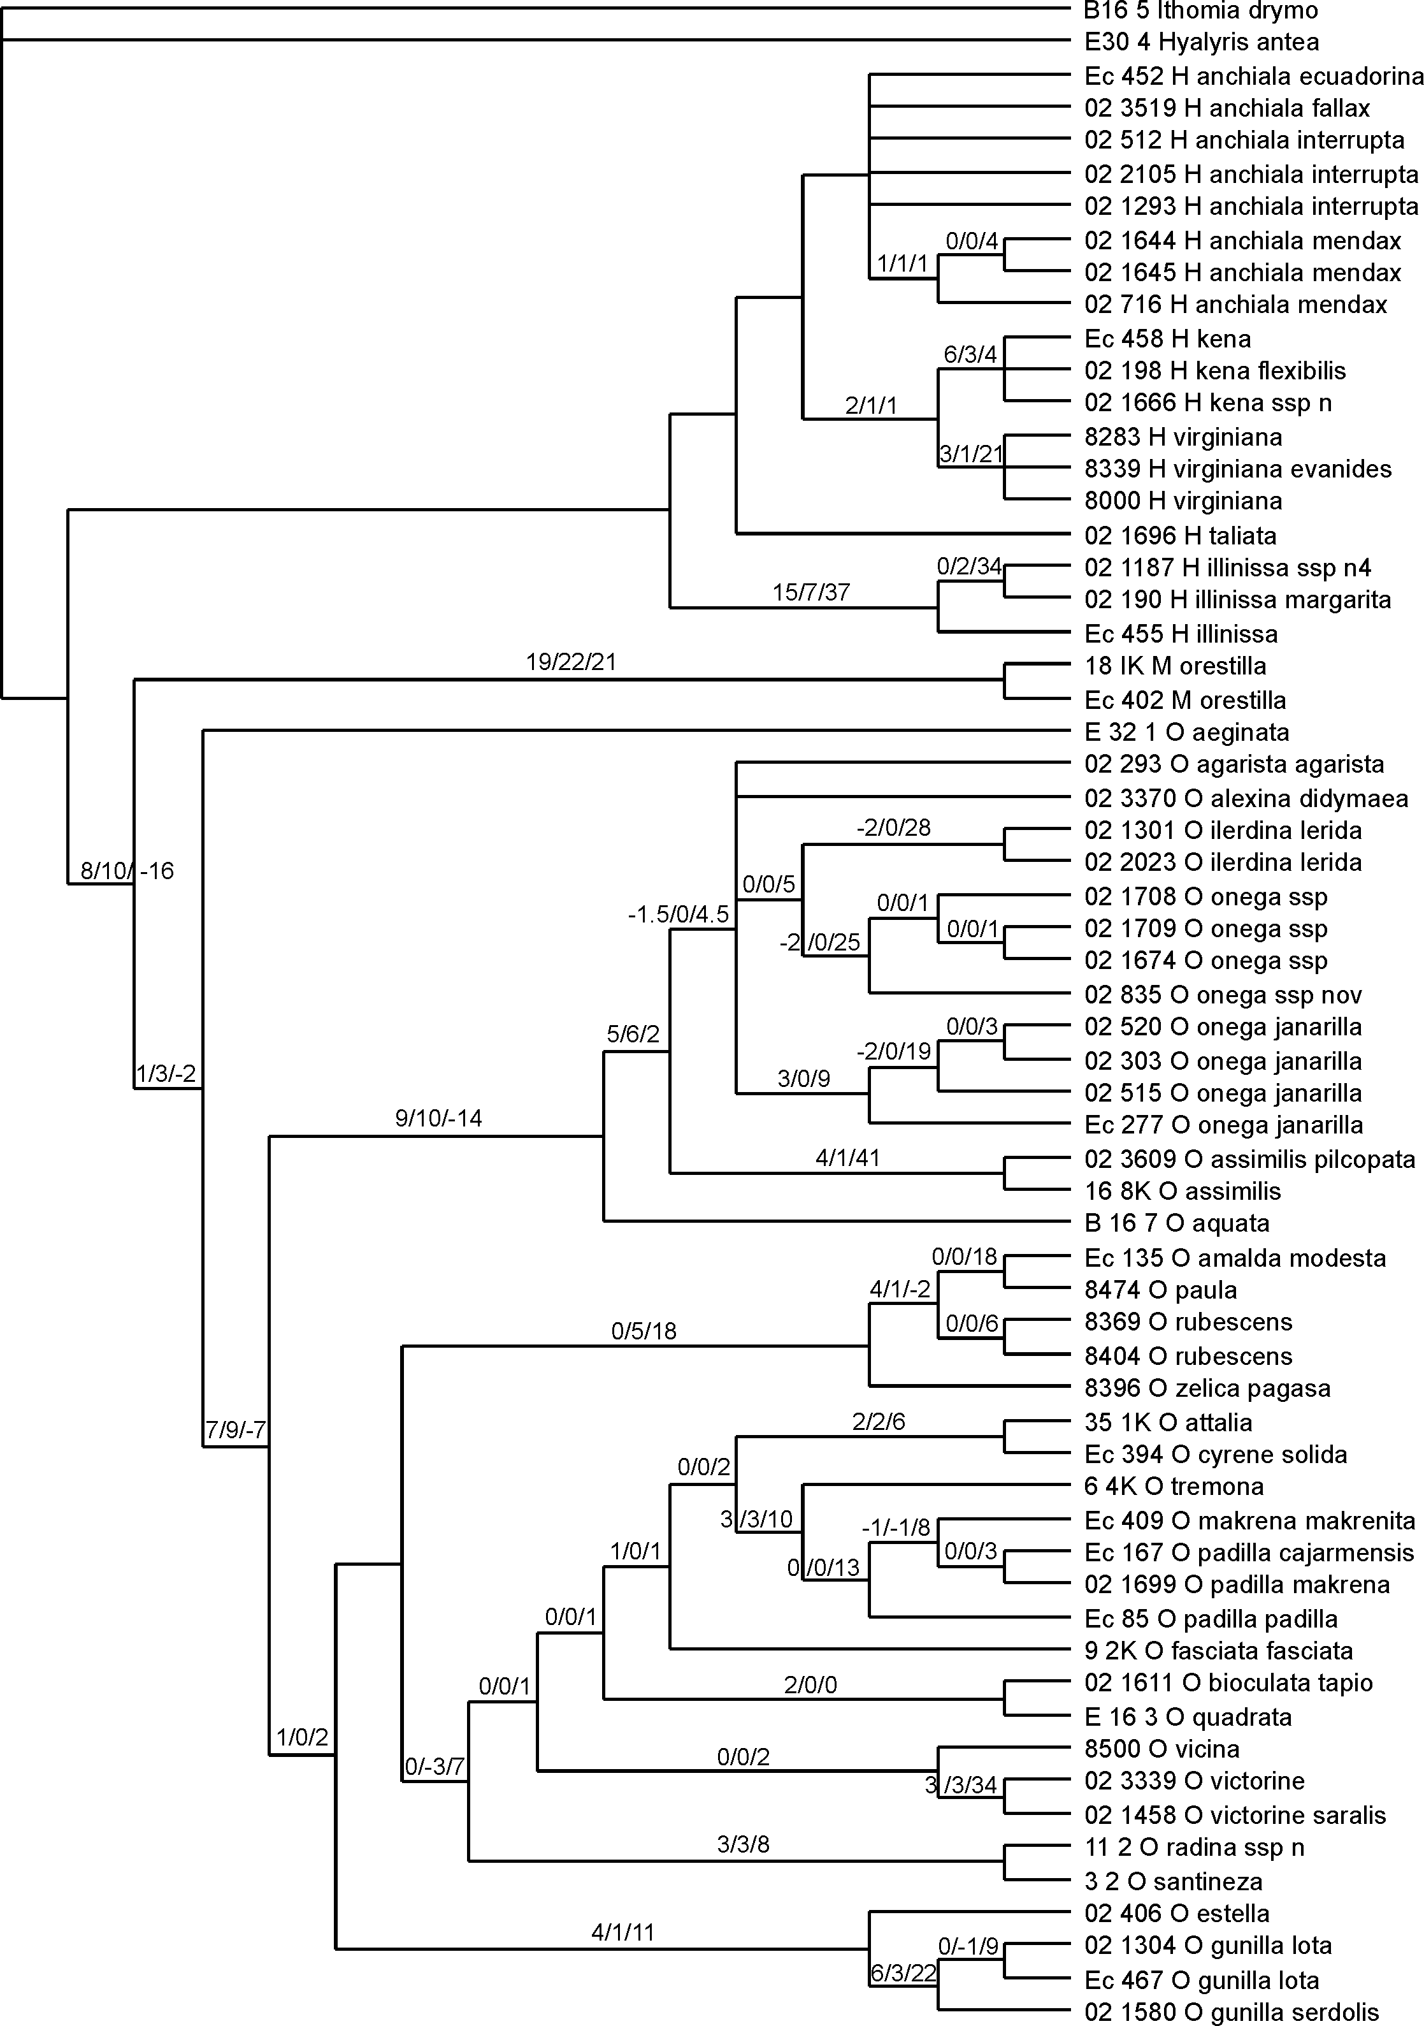

Figure 2. Phylogenetic hypothesis based on wg data, inferred with neighbour joining. Neighbour joining bootstrap values are given along branches.

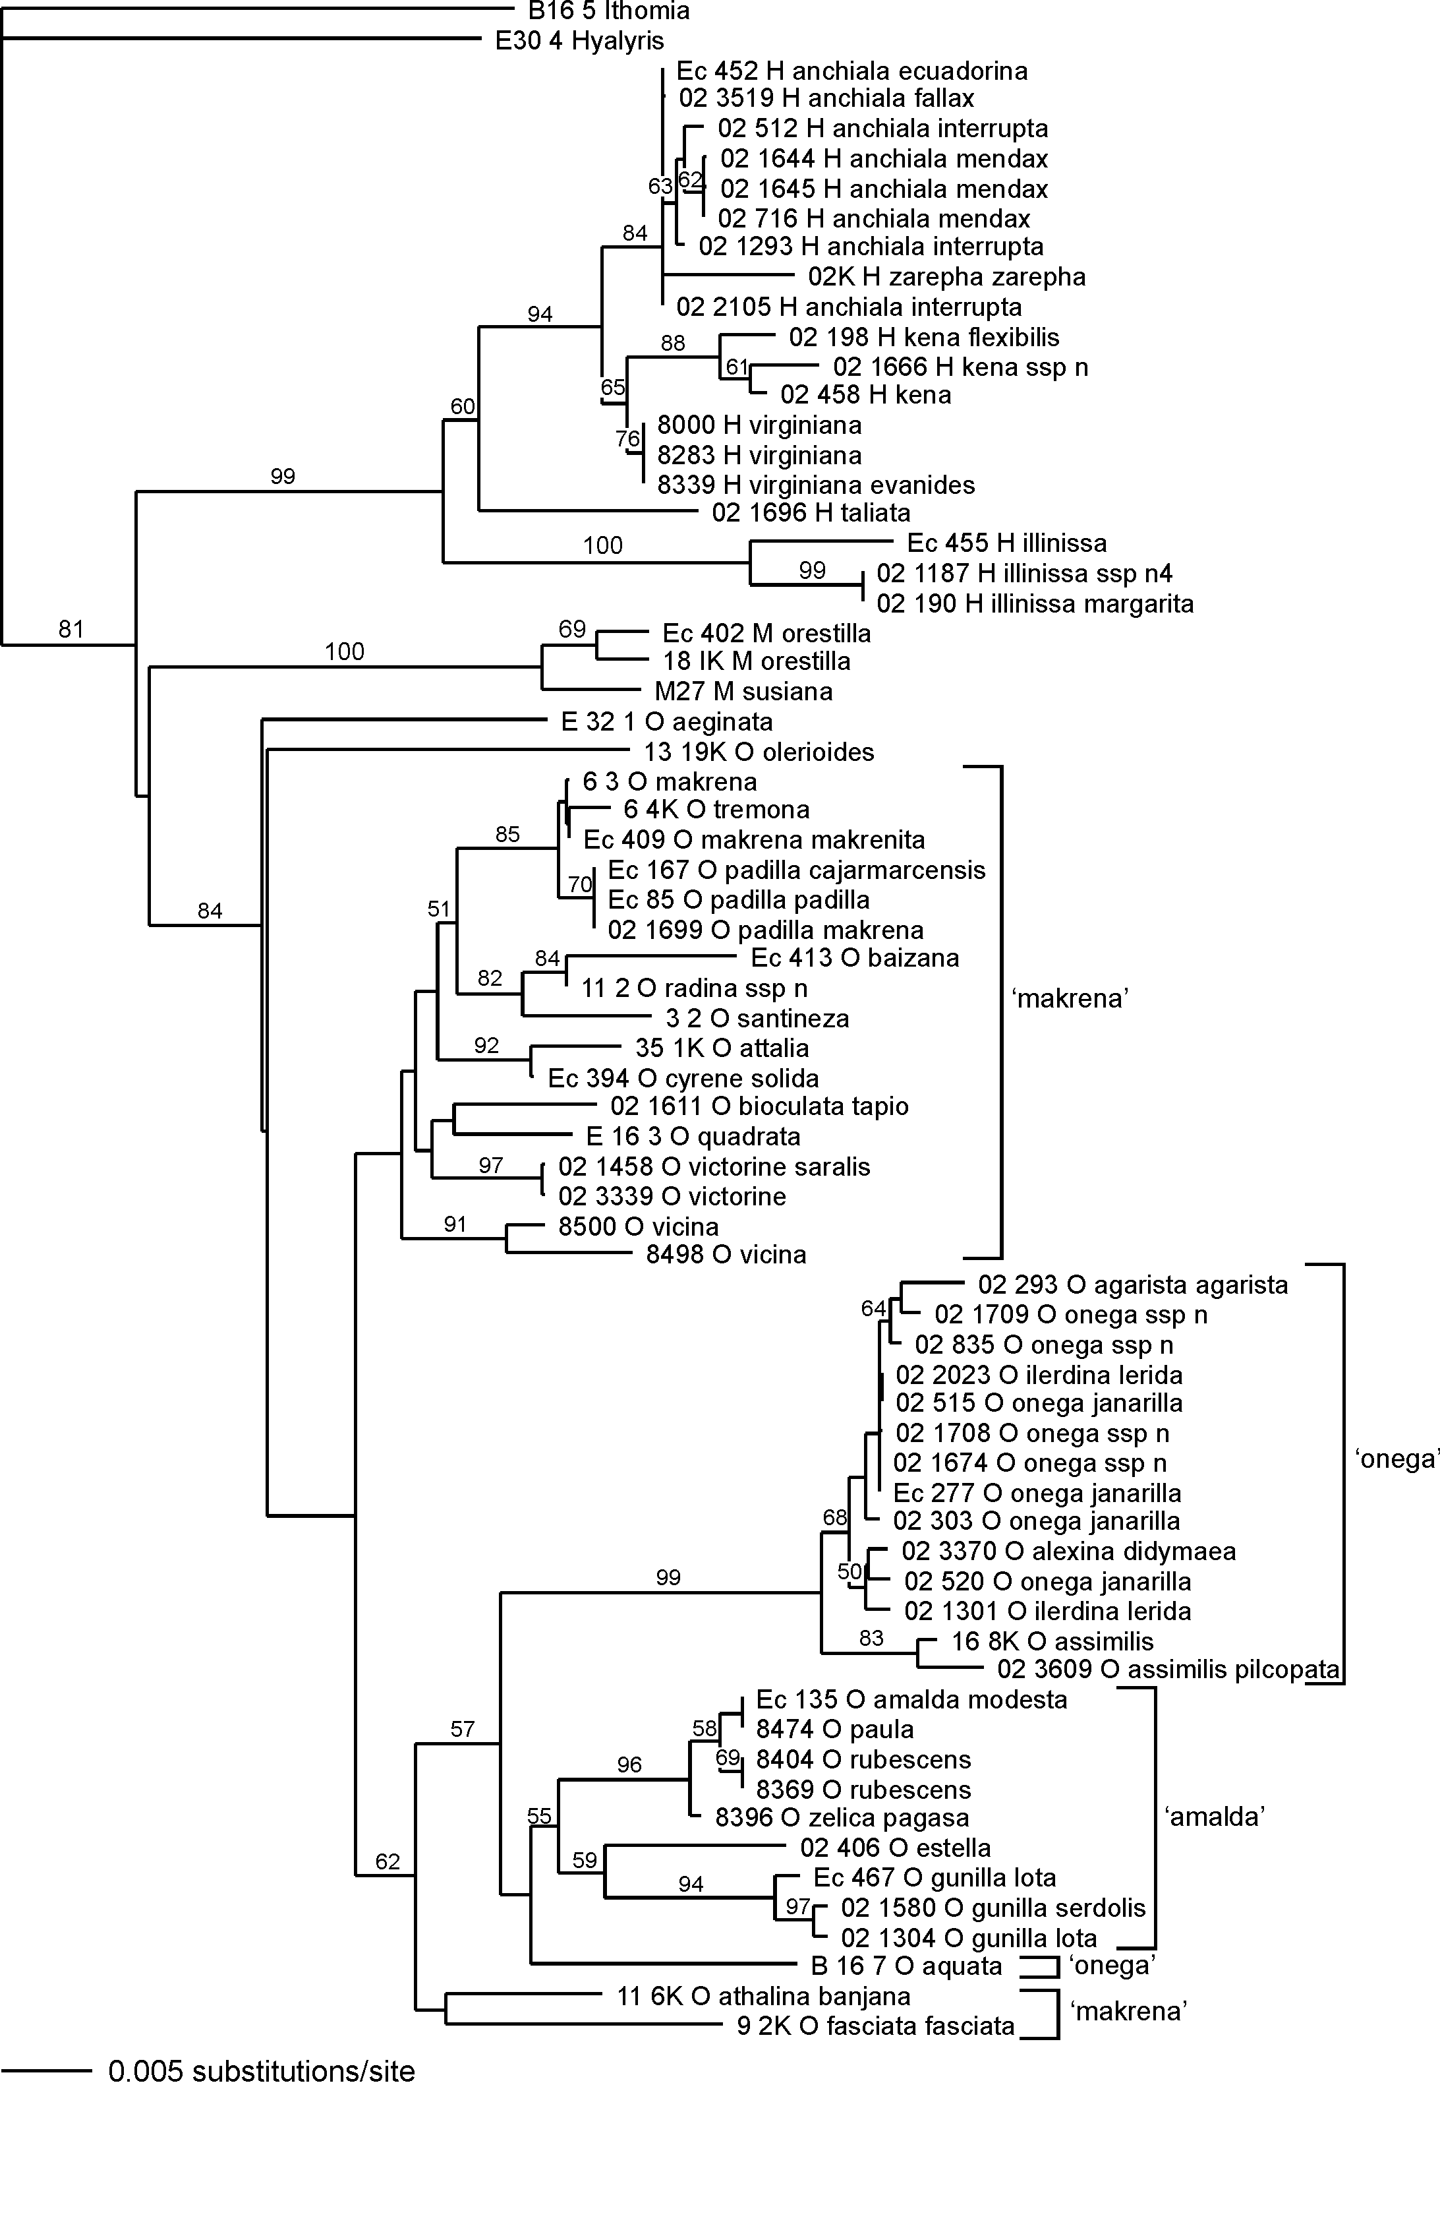
Figure 3. Phylogenetic hypothesis based on Ef1α data, inferred with neighbour joining. Neighbour joining bootstrap values are given along branches.

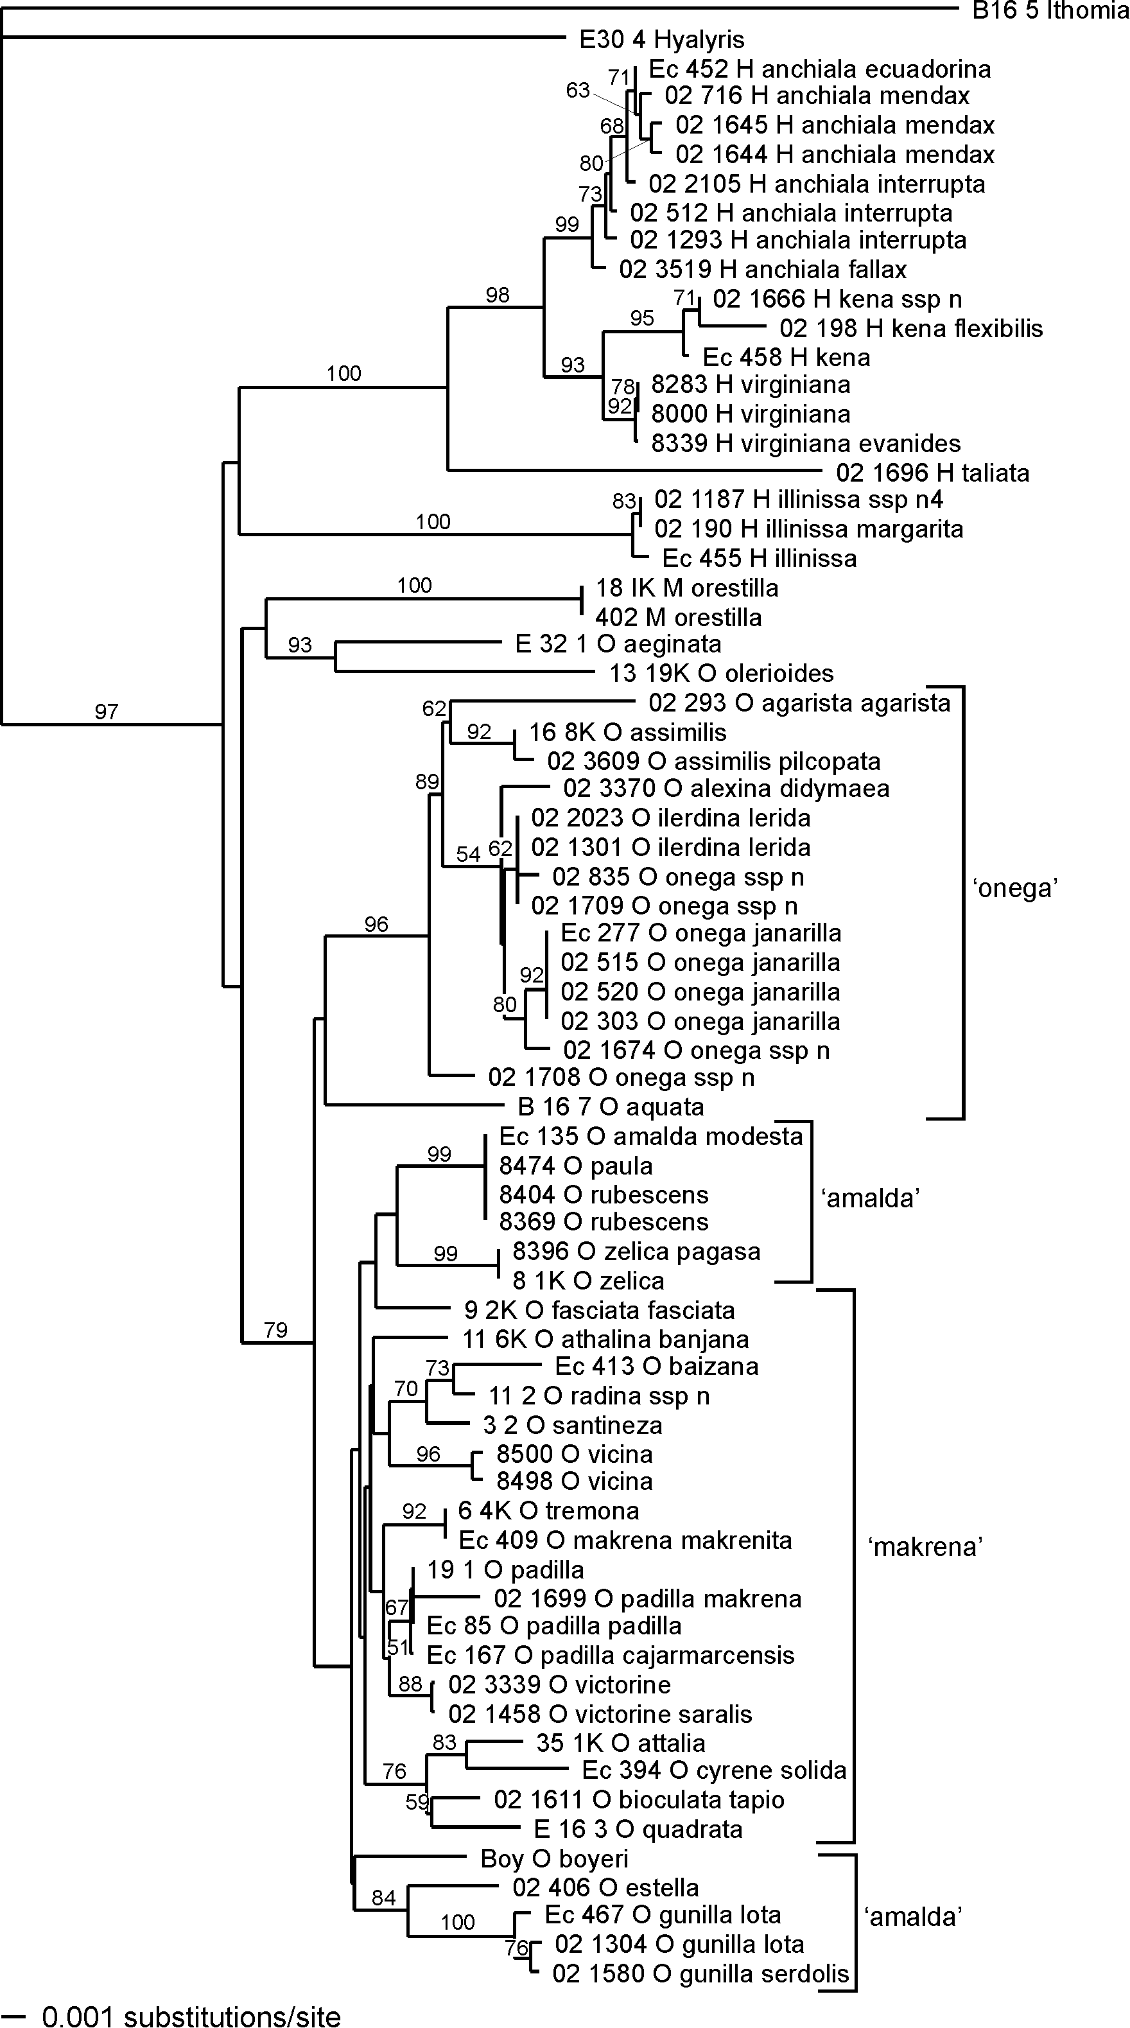
Figure 4. Phylogenetic hypothesis based on mitochondrial data, inferred with neighbour joining. Neighbour joining bootstrap values are given along branches.

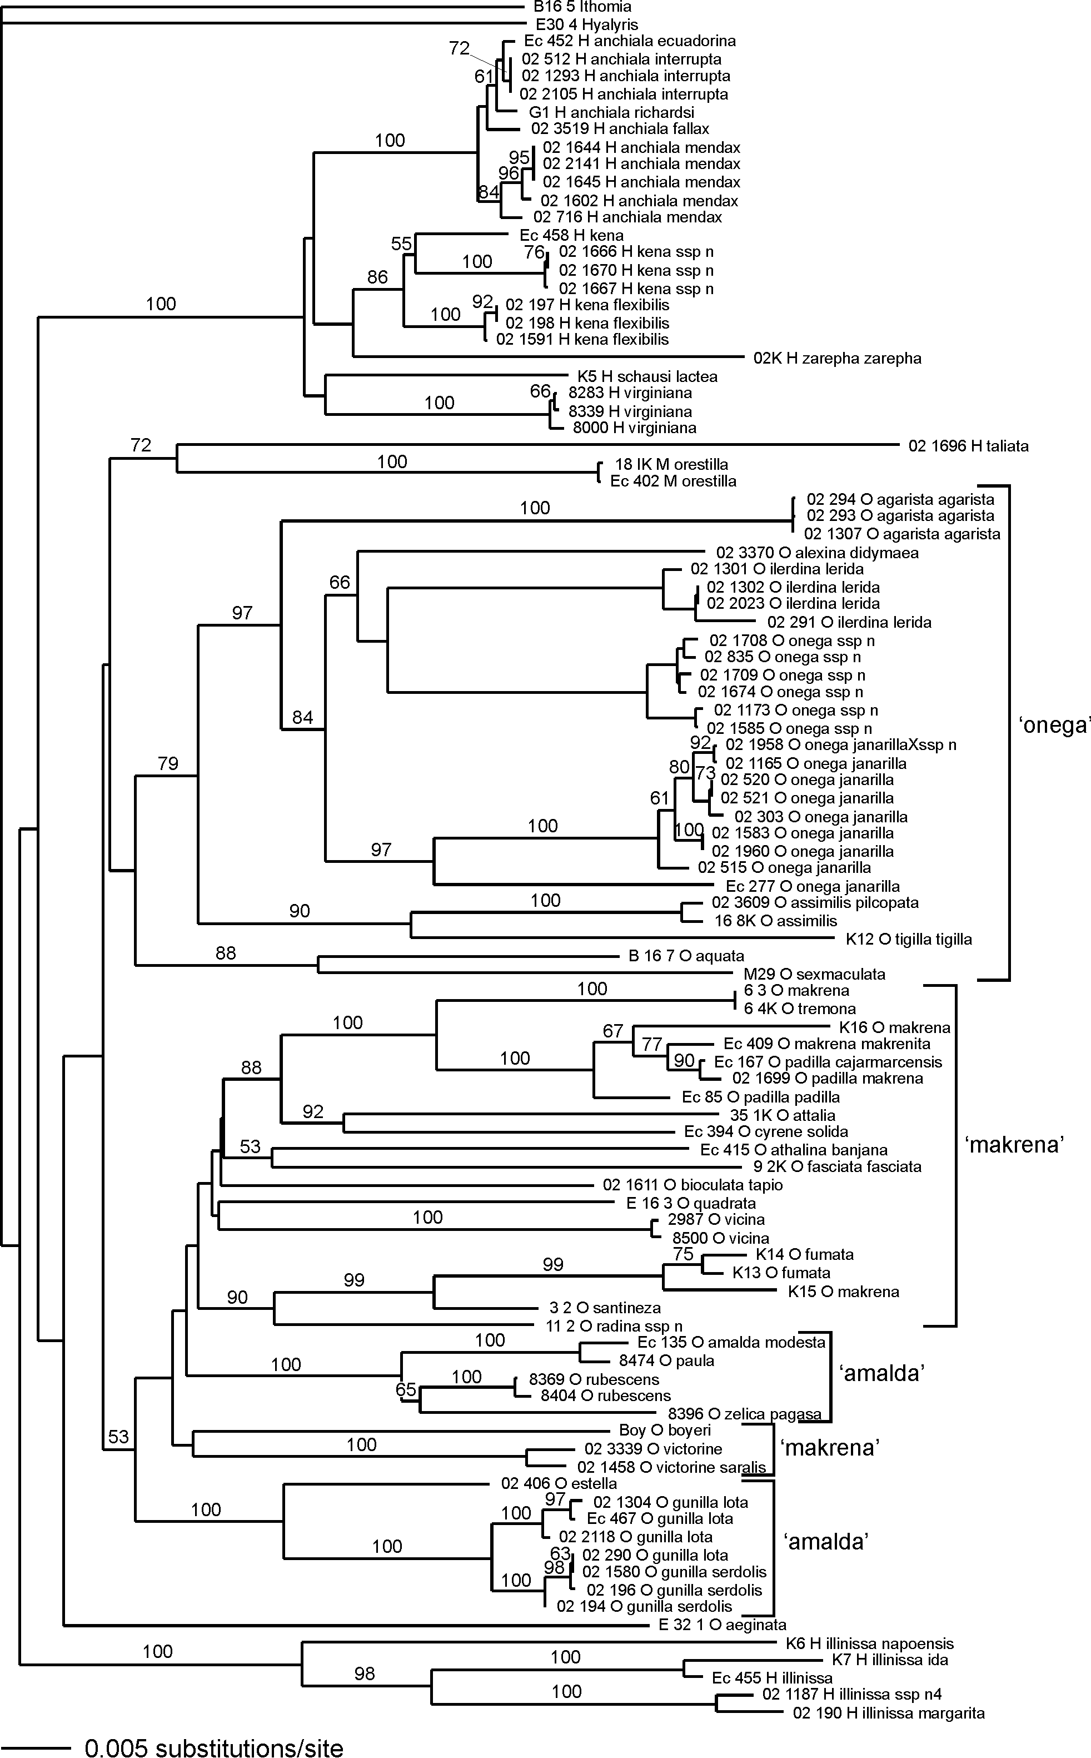
Figure 5. Phylogenetic hypothesis based on ‘complete’ data, inferred with neighbour joining. Neighbour joining bootstrap values are given along branches.

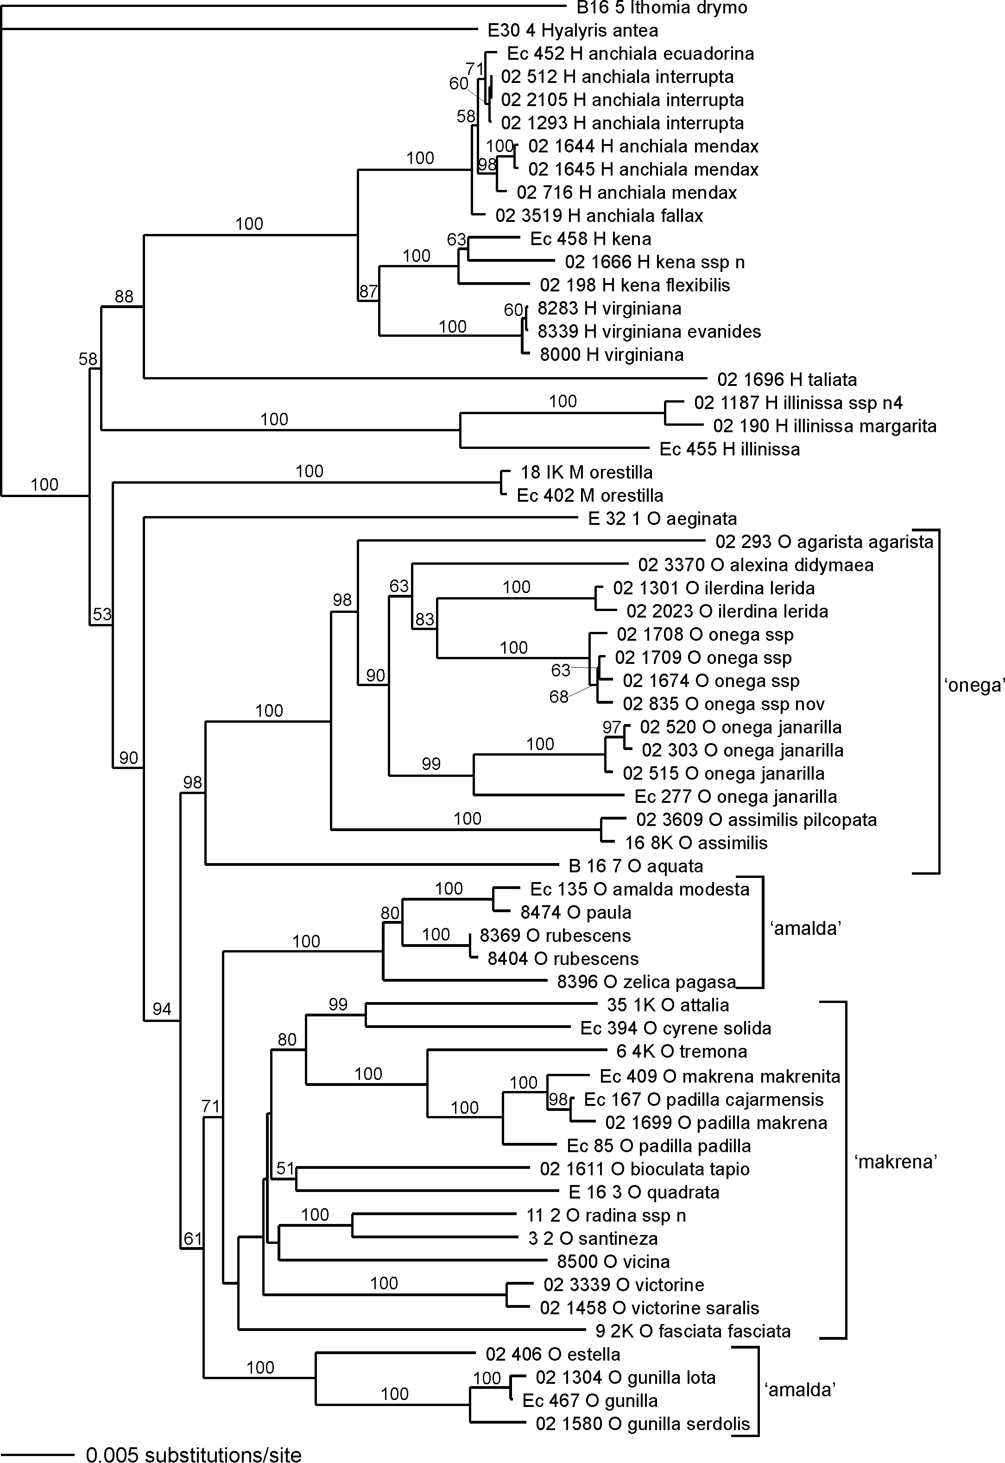

Figure 6. Phylogenetic hypothesis based on total data, inferred with neighbour joining.

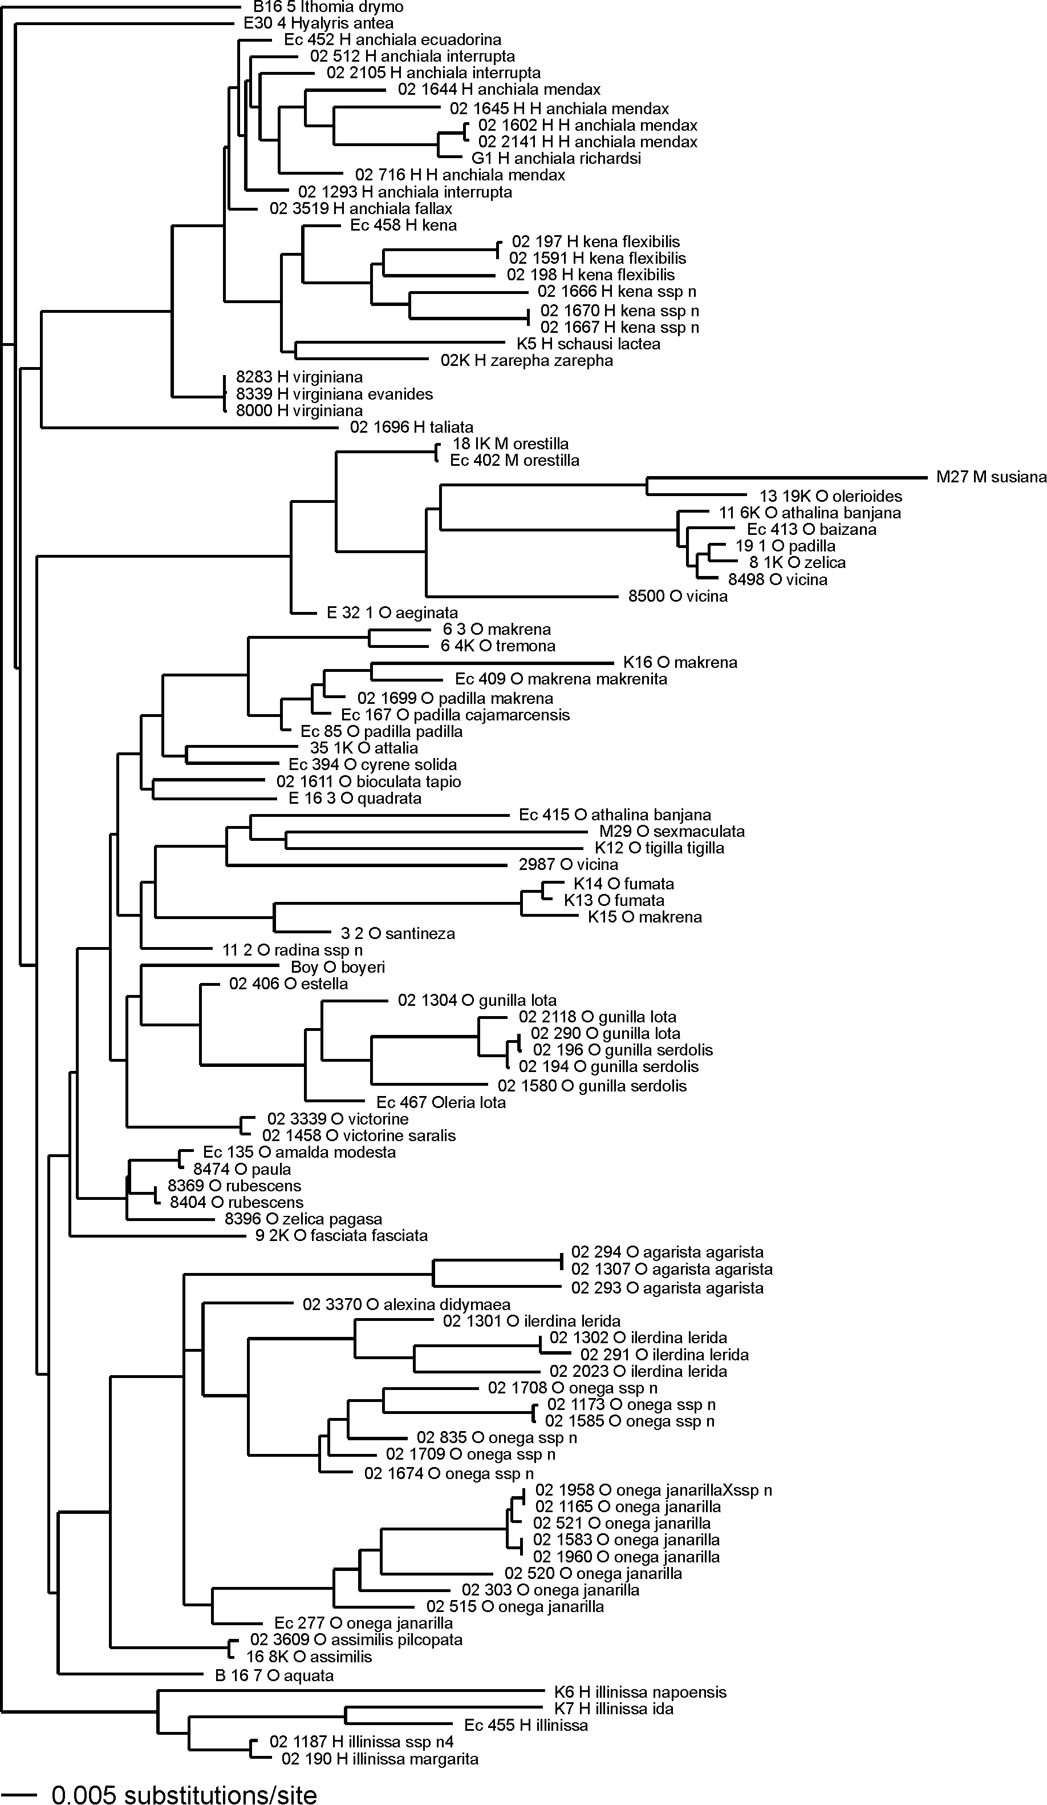
Figure 7. Phylogenetic hypothesis based on ‘complete’ data. Tree topology is consensus of the last 9,000 trees inferred using Bayesian methods.

